Rayleigh have got the 'Back to Netball' bug.



**Digi-News**

**February ‘15**

**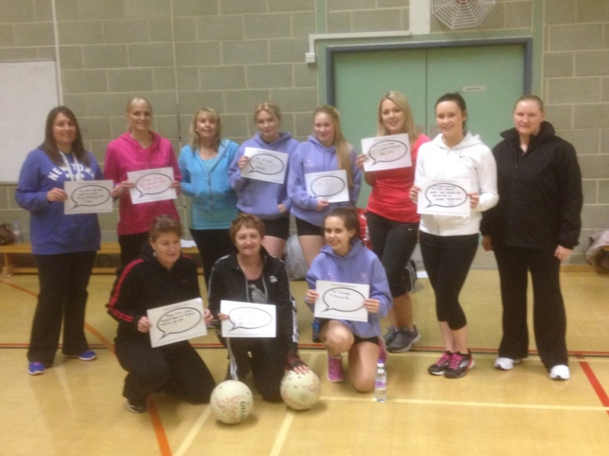**Essex NDO Clare Popperwell started working with Rochford sports development officer Mark Aldous in April 2014, to try and implement some back to netball in the Rayleigh area. After eventually securing Sweyne Park School as a venue and Jenna Lambeth as coach, the sessions began on Thursday 15th January 2015. Now everyone in Rayleigh has ‘netball fever’, with over 50 ladies currently engaged in the sport.

When promoting the sessions initially, we never expected them to be so popular in this area. Within the first few weeks of promotion, we had 15 ladies booked on, and they just kept coming! The first session went down brilliantly with 25 ladies in attendance, and we still had enquiries coming through. Thanks to the fantastic promotional help of Mark at Rochford District Council, contacting the local newspapers, many of our ladies heard about the session here along with seeing adverts on social media and the internet.

After just one session, we had some great feedback already from one lady;

“I've just attended the back to netball class at Sweyne School and wanted to say how much I enjoyed it. It's been 23 years since I last played but I still got the same buzz! Some of us were discussing about getting a school mums team up and running and wanted to know how to do this”?

After just 3 weeks into the sessions, the ladies are already excited to plan how they can become a team. We now also have a waiting list of 25 ladies who couldn’t get onto the first session. With the fantastic help of the coach Jenna, we are able to run another 10 weeks of sessions for these ladies on the waiting list, and more enquiries are still coming through, so watch this space for a new big netball club in Rayleigh!

Their coach Jenna says;

“They are a lovely group! Great ability too, so hopefully everyone is feeling well worked after the sessions. Everyone seems to really enjoy themselves. We start each session with a warm up, dynamic stretching and always make sure our fingers are supple with some passing. I try and coach a new skill each week and so far we have covered defence, shooting and footwork”.

Clare is meeting with the ladies on Thursday 19th February 2015 to see how they are getting on, to chat to them about becoming a club and how they can get involved in more events and matches!

Mavericks Youth v Lightning Youth - Saturday 7th February 2015



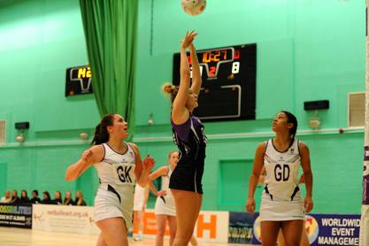Mavericks Youth hosted Lightning Youth for the first home game of the season held at The Hertfordshire Sports Village, Hatfield.

In front of a good crowd Mavericks were quick out of the blocks scoring 5 times before Lightning changed the scoreboard. Excellent defending from Beth Hatherly, Vicki Oyesola and Aimee Hatley enabled the attacking mid court Ellie Newman and Beth Dix to feed fine balls into shooters George Fisher and Laura Morton to convert the turnovers. Mavericks end with a credible 17-7 first quarter lead.

Head Coach Sam Meade made one change going into the 2nd quarter with Ellie Newman moving to WA and Beth Dix dropping back to C. The defence continued to put Lightning under immense pressure with turnovers continuing, fantastic attacking play and accurate shooting, Mavericks had a healthy 35-18 lead at half time.

Only one change from Mavericks in the 3rd quarter with Ellie Durr replacing Aimee Hatley as WD. Lightning made a number of changes in the hope of recovering the deficit but were unsuccessful. Flying interceptions from Vicki in defence, the patience of the mid court and great movement and shooting from George and Laura, the goals just kept coming. The quarter ending with a 32 goal lead 54–22.

Going into the 4th quarter Beth Dix and George Fisher were rested, Georgia Satwick came on as WA, Sophia Sefton as GS and Ellie Newman went back to C. Sophia shot with confidence and the intelligent netball shown all through the game continued right through to the end. With seconds to go, attempts were made to round the score to 70 but the squad accepted a well-deserved 69-35 win.

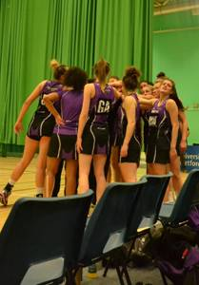

**Squad:**

**Starting 7**: GS George Fisher GA Laura Morton WA Beth Dix C Ellie Newman WD Aimee Hatley GD Vicky Oyesola GK Beth Hatherly

**Bench**: Georgia Satwick, Ellie Durr, Olivia Eastwood-Gray, Anna Hunt, Sophia Sefton.

**Coaches’ player of the match:** Vicki Oyesola

**Players’ player of the match:** Sophia Sefton

Written by Lynn Hatley, thanks to Lee @ Scrumpix for the photo



England Netball supports ‘Net 10 for Life’ 2015



## \\fileserver2k8\DATA\!Branding & Marketing\E&T\Officiating\Logo\OMtG_Whiteball.jpg\\fileserver2k8\DATA\!Branding & Marketing\E&T\Coaching\Logo\CMtG_Whiteball.jpgDATES FOR YOUR DIARY…



**UKCC COACHING COURSES**

**UKCC Level 1**

* **Univeristy of East Anglia, Norfolk, 11th April & 9th May 2015**
* **Bottisham Sports Centre, Bottisham, Cambs, 16th May & 13th June 2015**

**UKCC Level 2**

* **Abbey Croft Leisure, Bury St Edmunds, Suffolk: 12/13th Sept, 10/11th Oct & 8th Nov**



**HIGH 5 COACHING WORKSHOPS**

* **Epping St John School, Eppring, Essex: 6pm-9pm, Tuesday 10th March 2015**
* **City Academy, Norwich, Norfolk: 12.30-3.30pm, Wed 18th March 2015**

**TIME TO LISTEN COURSES**

* **Further courses planned for 2015-16**

**MAVERICKS AND NETBALL EAST**

* **Match Analysis** – Sat 14th March 2015;

11am - 4pm at Herts Sports, Hertfordshire

Delivered by Maggie Jackson (including ticket to sold out Mavericks match v Celtic Dragon)

* **Academy Workshop** – Thurs 19th March 2015;

6.30-9.30pm at Braintree College, Essex

Delivered by Maggie Jackson & Sam Meade

* **Academy Workshop** – Wed 25th March 2015;

6.30-9.30pm at Oaklands College, Hertfordshire

Delivered by Maggie Jackson & Sam Meade

* **Speed Dating Workshop** –Sat 13th June 2015;

10am – 1pm at Cambridge Regional College, Cambridgeshire. Delivered by Olivia Murphy, Amanda Newton and Mel Mansfield

For more information including booking forms visit [www.netballeast.org.uk](http://www.netballeast.org.uk)

**OFFICIATING**

* **C Award, Essex, 8th March 2015**
* **B Award, Thetford Academy, Suffolk, 16th May 2015**
* **Further courses for 2015-16 TBA**

**TECHNICAL SKILL COACHING WORKSHOPS**

**Activate:**

* **Westbourne Academy in Suffolk: 10am to 1pm, Saturday 14th March 2015**

**Sharp Shooting:**

* **Hassenbrook Academy, Essex: 6.30- 9.30pm, Tuesday 3rd March 2015**



## GET YOUR MAVERICKS TICKETS NOW

Mavericks season tickets sold out in extra quick time but that doesn’t mean you have to miss out from watching the best superleague franchise. To buy your tickets for the 2015 season please visit:

[***www.Mavericksnetball.co.uk***](http://www.Mavericksnetball.co.uk)