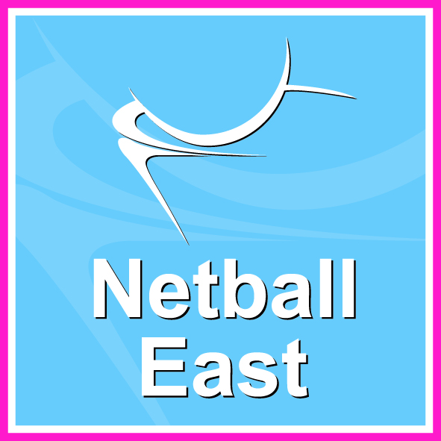
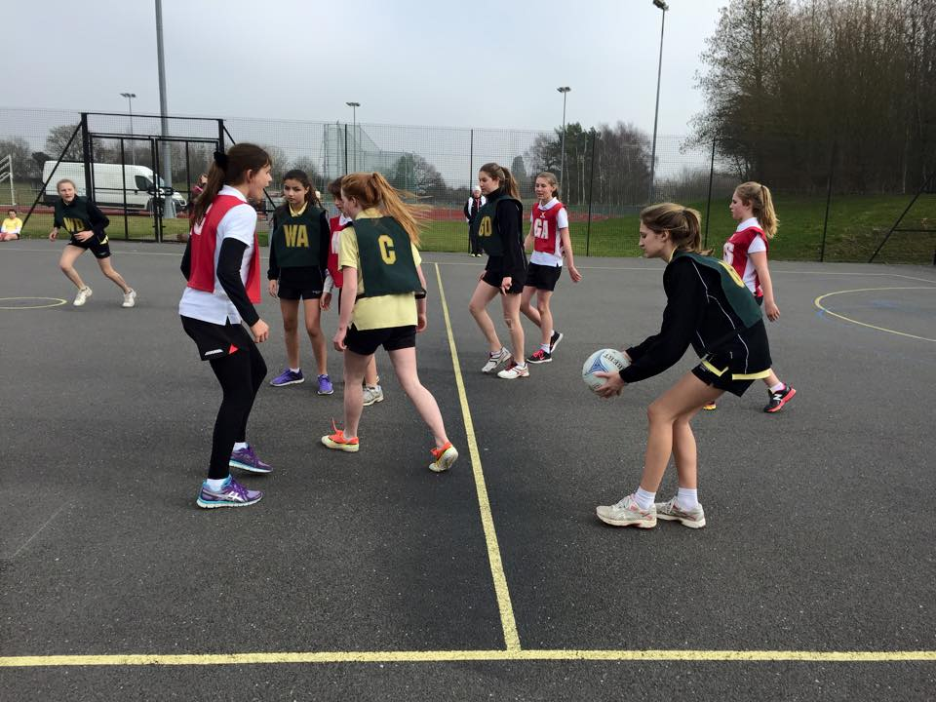
Emerging Schools Festival 2015
Digi-News
March ‘15

As Hertfordshire County Netball Association aim to provide competitive provision for the less established netballing schools in the county, we ran our second annual Emerging Schools Netball festival on Wednesday 18th March. As a Herts School Games event, we invited schools from across the County who had not entered National Schools or the St Albans Invitational tournament in the last two years to enter a Year 9 team. We had a fantastic entry of 11 schools from across the whole county come down to Wodson Park in Ware for the festival.
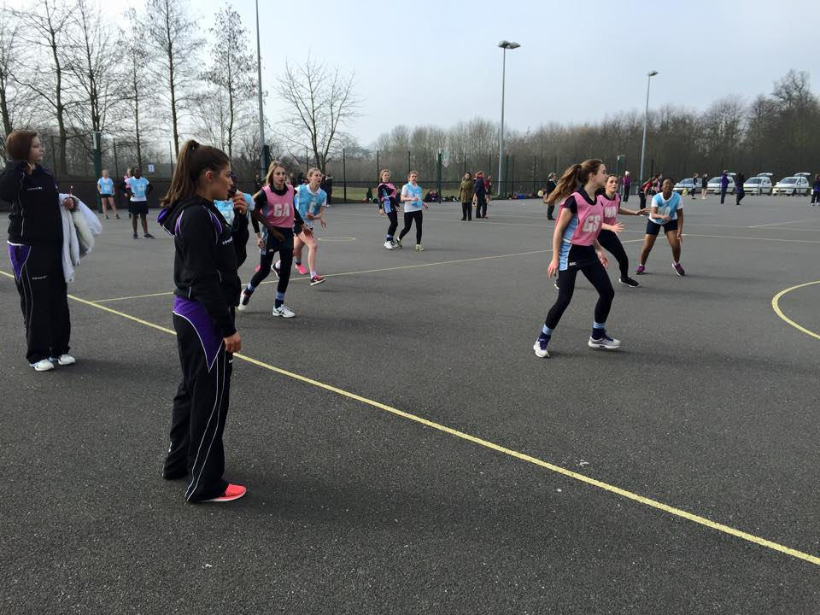
The day started off with a chilly start as the teams played in a round robin competition taking on every school in their pool, with some great Netball being played. The girls stayed enthusiastic throughout the whole morning and spirits remained high. With the help of June Griffith (Herts Competitions and Young people Chair) overseeing the match timing, we managed to run ahead of schedule with quick change overs. By the end of all the morning games, St. Christopher’s School and John Warner remained unbeaten, followed closely by Queens and Turnford.
We were very lucky to be supported by 12 girls from Oaklands College Netball Academy, who came for the whole day to umpire and score all of the games. We have a great relationship with the College, offering opportunities to upskill their Netballers and Sport students.
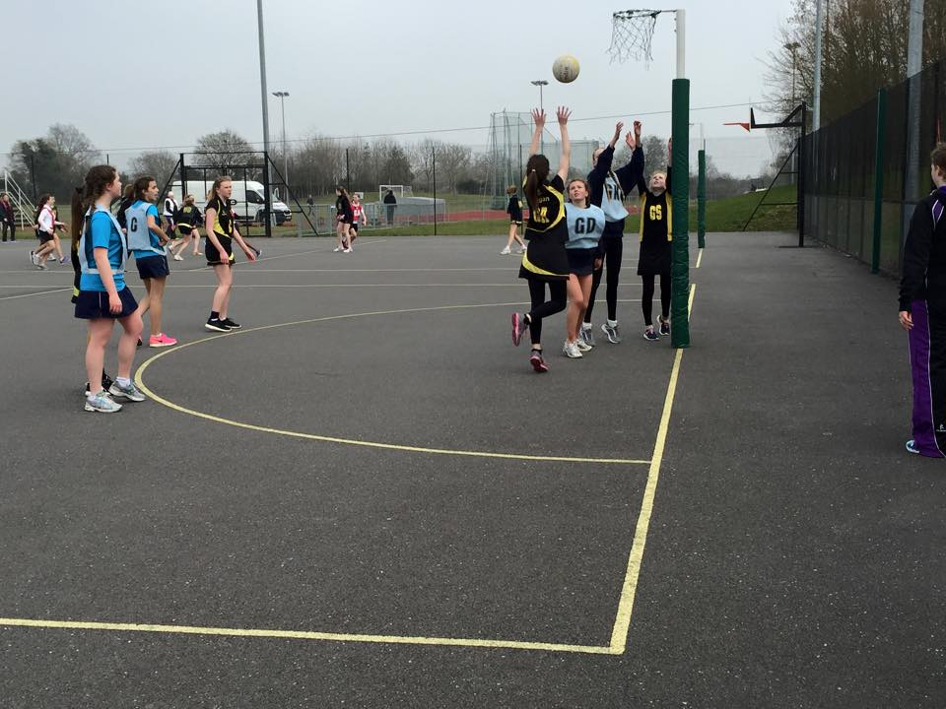
The umpires and helpers were also tasked with spotting a team for the ‘Team of the day’ award. This was awarded to Sheredes School who although did not win one game, remained positive, smiley and had a great team spirit, with their teacher and substitutes cheering throughout the whole day from the side lines.
The end result left John Warner in 1st place, closely followed by Queens School and in 3rd place came St Christopher’s school. The winner of the second pool was Roundwood Park who walked away with the plate.
It was a fantastic day for all involved and it was good to see some new faces and a variety of schools from different Districts and Boroughs. We cannot wait till next year!
UNO Netball at University of East Anglia (UEA)
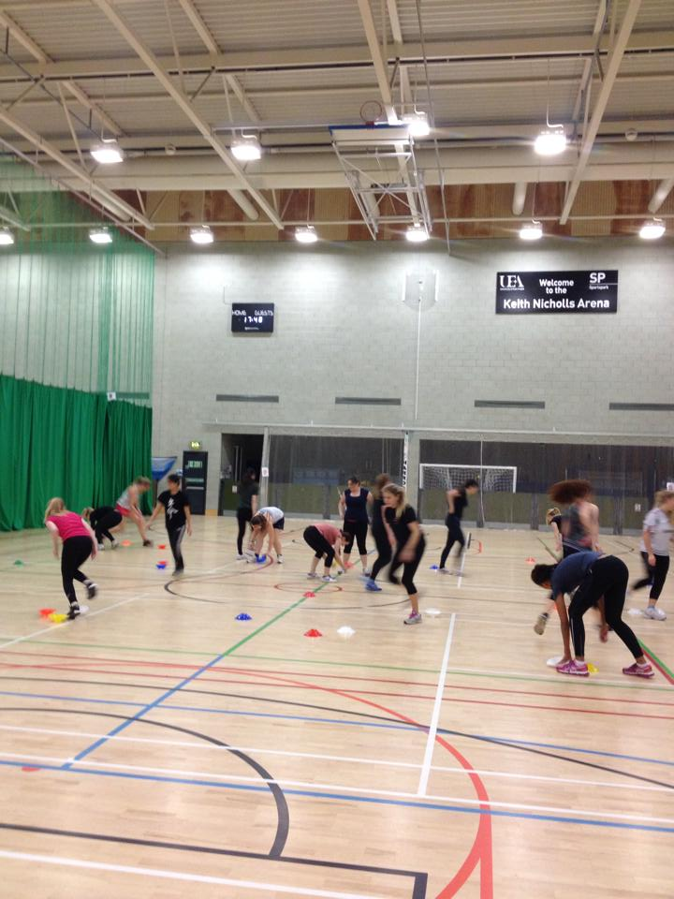
The England Netball University Netball Officer (UNO) programme is about increasing participation and awareness of netball. It focuses specifically on university age students.
As an UNO I have numerous methods to increasing participation. I hold a Netball Now session every week, where participants can pay a £1 to play netball and socialise with other participants. I also run an intramural league fortnightly, where anyone can get a team together and play matches for two hours on a Sunday. We had a Christmas spectacular at the end of last year where we invited basketball and korfball to a Christmas themed tournament. This was a great way to interact with other sports people and also just great fun.
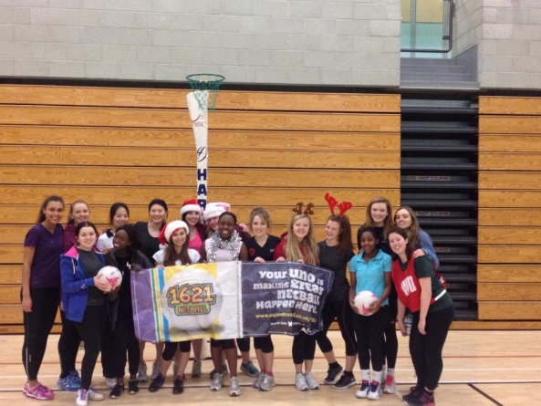
All of these programmes are non - commitment and don't require any prior knowledge of netball to take part. At the UNO programme we are all about participation and enjoyment of netball, no matter what level an individual is at. The UNO programme has seen a lot of success in the first term with over 73 people taking part in at least one event. The second term is shaping up to be even bigger and better.

Netball East Regional Assembly 2015
On Saturday 13th June 2015, Netball East will be holding their annual Regional Assembly, including their AGM and Regional and Goalden Globe Awards. The event will be held at the Cambridge Regional College, Kings Hedges Road, Cambridge CB4 2QT.
The Assembly will be split into two parts, with morning sessions by invitation only as well as a Mavericks Coaching workshop (for more information about the workshop or a booking form, please visit www.netballeast.org.uk).

All affiliated Netball East Members, including Clubs and Schools are invited to join the Assembly for lunch and the afternoon sessions. For more information visit www.netballeast.org.uk

Volunteering Opportunities - International Netball Series, England v Trinidad & Tobago
England Netball is delighted to inform everyone that it has launched its volunteering opportunities for the International Netball Series against Trinidad and Tobago. This series England Netball have more opportunities to volunteer than ever and the organisation would be delighted to see you all there. To apply and see what roles are available, please visit the England Netball website and if you have any queries or would like to apply, please e-mail: volunteering@englandnetball.co.uk.

Deaf Women’s’ Netball Tournament
On Saturday 9th May from 11am to 4pm at Action Indoor Centre, Birmingham, England Netball will be working with BID Services. For more information regarding team entry or to be a volunteer on the day (organiser, official, etc.) please visit: www.netballeast.org.uk.
Our very own Sasha Corbin has also created a video if you want to learn the netball symbols (Footwork, Obstruction) in BSL Sign language visit
https://youtu.be/5LaV4zJ31m0.

England Netball is proud to launch this new competition for 16-19 year olds. Enter with your club, school, college or group of friends for a fun and competitive weekend of netball.
When: 4th – 5th July 2015
Where: Redbridge Sports Centre, Barkingside, Essex IG6 3HD
Who: 16-19 year olds in a team either through a Club, School, College, University or a group of friends who form a team for this
Price: £110 per team
How to enter: visit www.englandnetball.co.uk
Closing date for entries: Friday 5th June 2015

DATES FOR YOUR DIARY…
UKCC COACHING COURSES
UKCC Level 1
- Univeristy of East Anglia, Norfolk, 11th April & 9th May 2015
- Bottisham Sports Centre, Bottisham, Cambs, 16th May & 13th June 2015
- Braintree College, BrIaintree, Essex, 4th July & 25th July 2015

UKCC Level 2
- Abbey Croft Leisure, Bury St Edmunds, Suffolk: 12/13th Sept, 10/11th Oct & 8th Nov

HIGH 5 COACHING WORKSHOPS
- Further courses to be planned in each county from September 2015
TIME TO LISTEN COURSES
- Further courses planned for 2015-16 to register your interest and receive information directly email east@englandnetball.co.uk

MAVERICKS AND NETBALL EAST
- Speed Dating Workshop –Sat 13th June 2015; 10am – 1pm at Cambridge Regional College, Cambridgeshire. Delivered by Olivia Murphy, Amanda Newton and Mel Mansfield.

- Mavericks Youth Match v Surrey Storm– Mon 6th April 2015, 11.30am at the University of Hertfordshire, Hatfield (free entry)

- End of Season Netball Tournament -
(3 categories: U16/Open/Mixed)
Sun 3rd May 2015,
Wodson Park, Ware, Herts, SG12 0UQ
For more information including booking forms visit www.netballeast.org.uk

OFFICIATING
- Beginner, Hylands School, Chelmsford, Essex, 6th June 2015

- B Award, Maidenhall Sports Centre, Ipswich 16th May 2015

TECHNICAL SKILL COACHING WORKSHOPS
Sharp Shooting:
- Univesiry of East Anglia, Norwich, 7- 10pm, Wednesday 8th April 2015

Winning the Ball:
- Stowupland High School, Stowmarket, Suffolk, 6.30-9.30pm, Wed 15th July 2015

GET YOUR MAVERICKS TICKETS NOW

Mavericks tickets are nearly sold out but there is still one opportuntity to watch the best superleague franchise. Tickets are still availble for the home game v Yorkshire Jets at Redbridge Arena. To buy visit:
www.Mavericksnetball.co.uk

